SILo: Sistem Informasi Logistik

Use Case Specification: View Delivery Notes

Version 1.0

Revision History

|  |  |  |  |
| --- | --- | --- | --- |
| **Date** | **Version** | **Description** | **Author** |
| 01 Okt 2020 | 1.0 | Initiation | Daniel Siahaan |
|  |  |  |  |
|  |  |  |  |
|  |  |  |  |

Table of Contents

1. Insert Metadata 4

1.1 Brief Description 4

2. Flow of Events 4

2.1 Basic Flow 4

2.2 Alternative Flows 4

2.3 Exceptions 4

3. Special Requirements 4

4. Pre-Conditions 4

5. Post-Conditions 4

6. Extension Points 5

Use Case Specification: View Delivery Notes

# Insert Metadata

## Brief Description

This use case describes how the warehouse view the list of delivery notes. After viewing the list, the warehouse can manage each delivery note.

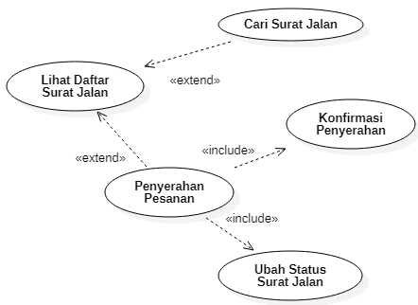

# Flow of Events

## Basic Flow

1. In the main page, Warehouse clicks **Delivery Notes** menu.

2. The system shows the list of delivery notes.

## Alternative Flows

n.a.

## Exceptions

2b.4.1a If there is one or more item unavailable, the order delivering is canceled.

2b.4.1a.1 The warehouse clicks on Pending button.

2b.4.1a.2 The system changes the status to ‘pending’.

# Special Requirements

1. Only authorized and authenticated warehouse may change the status of delivery note.
2. The list of delivery notes should display at least the following information: invoice number, delivery notes number, customer name, order date, delivery date, and status.

# Pre-Conditions

1. A new delivery note should have a ‘new’ status.

# Post-Conditions

1. The delivery date of a completed delivery note should be set to current date.

# Extension Points

2a The warehouse can **Search Delivery Note** to find delivery notes that matched specific keywords.

2a.1 The warehouse fill the keywords, then clicks the **Search** button.

2a.2 The system shows the list of matched delivery notes.

2b The warehouse can **Delivering Order** according to the delivery note.

2b.1 The warehouse click on **View** button of corresponding delivery note.

2b.2 The system shows the description of the delivery note.

2b.3 The warehouse **Change Delivery Note Status**

2b.3.1 The warehouse clicks **Preparing** buton.

2b.3.2. The system change the status of the delivery note to ‘preparing’

2b.4. After all items has been prepared, the warehouse asks the customer to for **Delivery Confirmation** to acknowledge the completion of the order.

2b.4.1 The customer physically checks the items as listed in the order, then the warehouse click on **Sign** button.

2b.4.2 The customer digitally signs the delivery note.

2b.4.3 The system changes the status of the delivery note to **completed**.